[CprE 381] Computer Organization and Assembly-Level Programming, Fall 2017

Project B - Report

Name(s) ___Zhanghao Wen______________________________________

Section /Lab Time _______B__________________

Refer to the highlighted language in the Project B instruction for the context of the following questions.
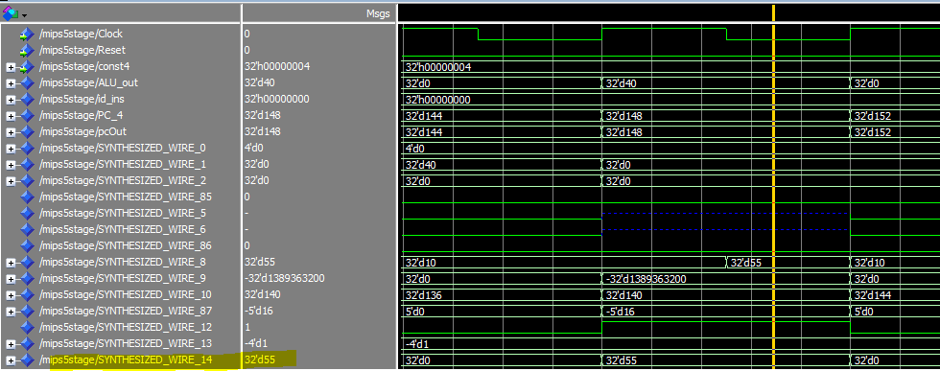
Imem,dmem.mif are the same as project A. the final result saved in the memory is also the same as project A. However, the difference is that this project takes much more cycles to execute.
- [Part. 3] Provide a description of a few test cases (at least one test case for each of the six instructions) and clear screenshots depicting your functioning test cases. (6 pts)
- ADD
- 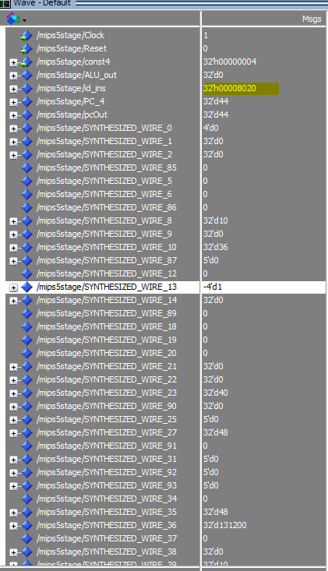
- ADDI
- 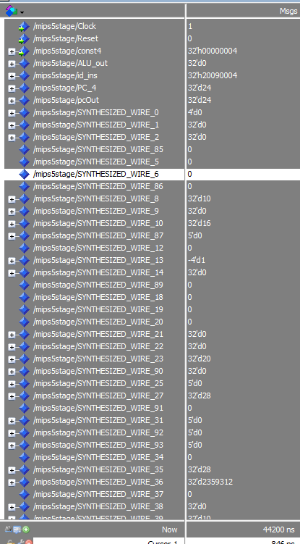
- LW
- 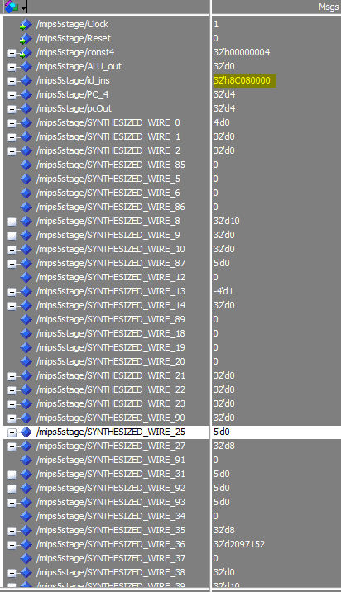
- 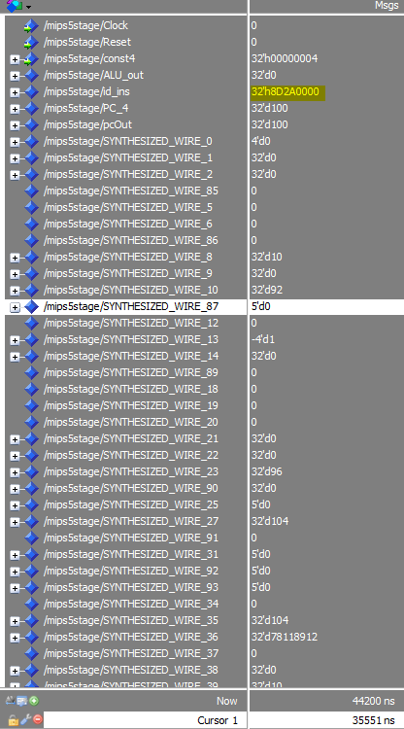
- SW
- 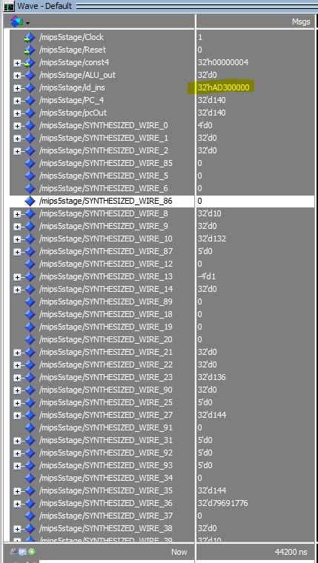
- BEQ
- 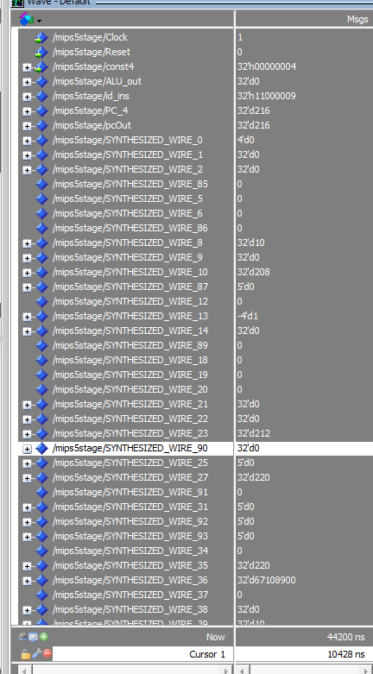
- J
- 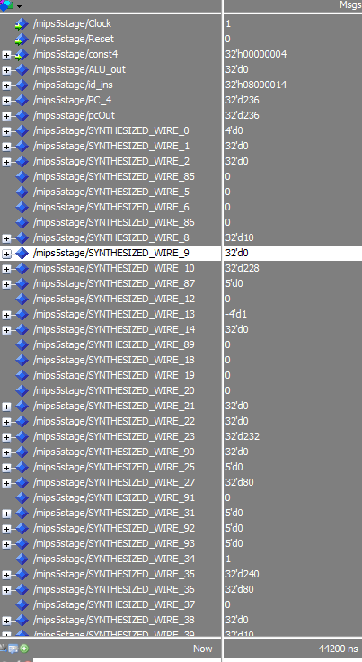

- [Part 4] Implement ID stage branch resolution and provide a legible simulation-screenshot of a taken-branch instruction correctly executing. (6 pts)
When 2 32bits are equal, the output return 1, otherwise, return 0;

Forwarding unit working, but hazard detection unit is not fully completed.
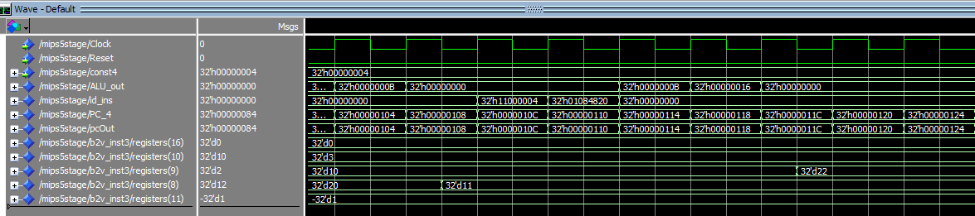
- [Part 5a] Implement a forwarding unit (using VHDL) to support the following data dependent cases. Give simulation screenshots of correct forwarding for each case: (6 pts)
- ALU producer to ALU consumer at distance 1 (e.g. ADD $1, $2, $3; ADD $4, $1, $2)
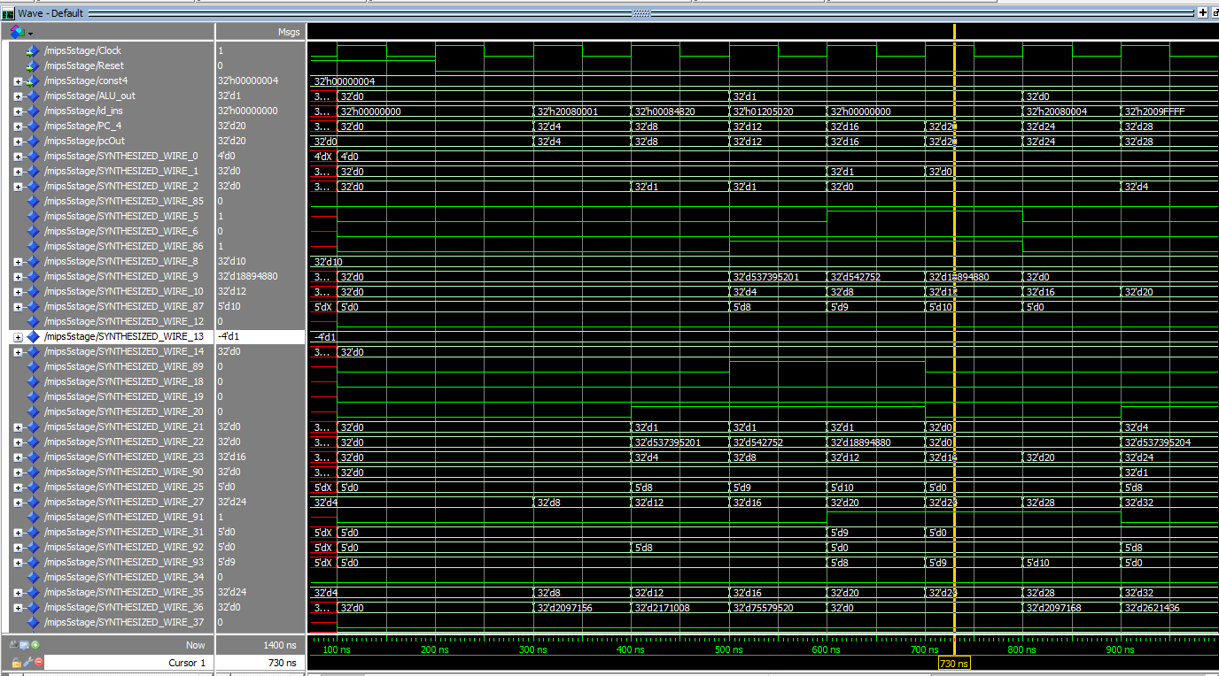
- ALU producer to ALU consumer at distance 2 (e.g. ADD $1, $2, $3; <INST>; ADD $4, $1, $2)
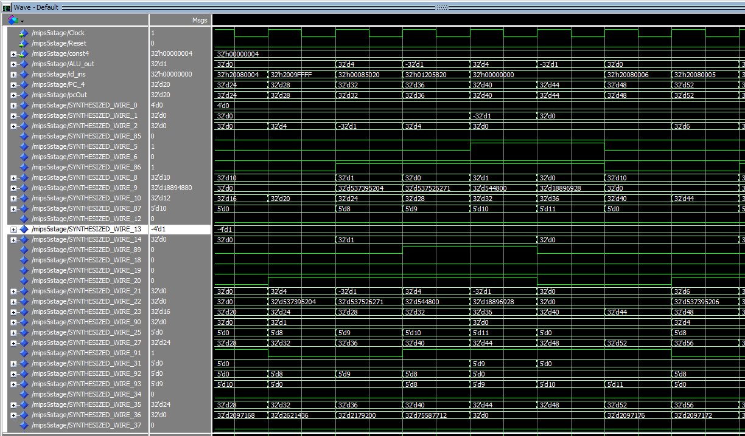
- Load producer to ALU consumer distance 2 (e.g. LW $1, 0($10); <INST>; ADD $5, $1, $r2)
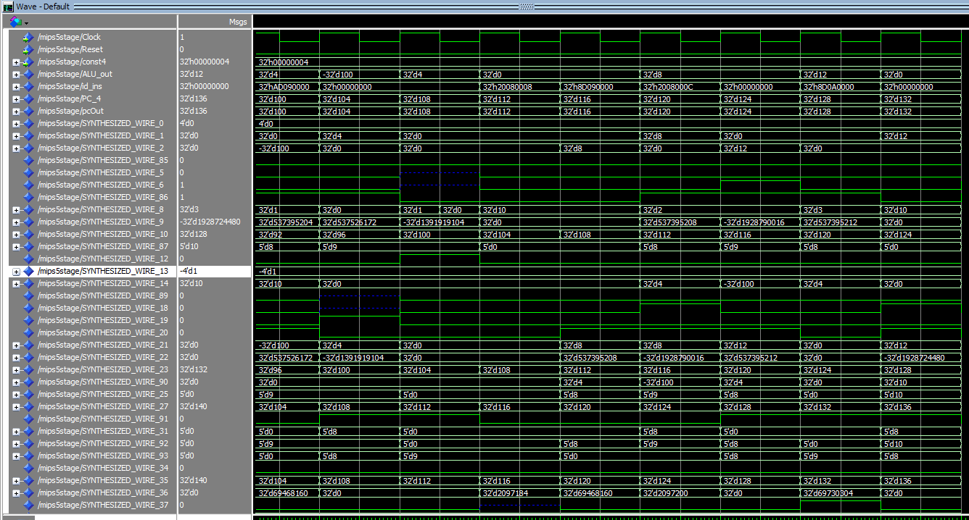
iv) ALU producer to BEQ consumer at distance 2 (e.g. ADD $1, $2, $3; <INST>; BEQ $1, $2, label)
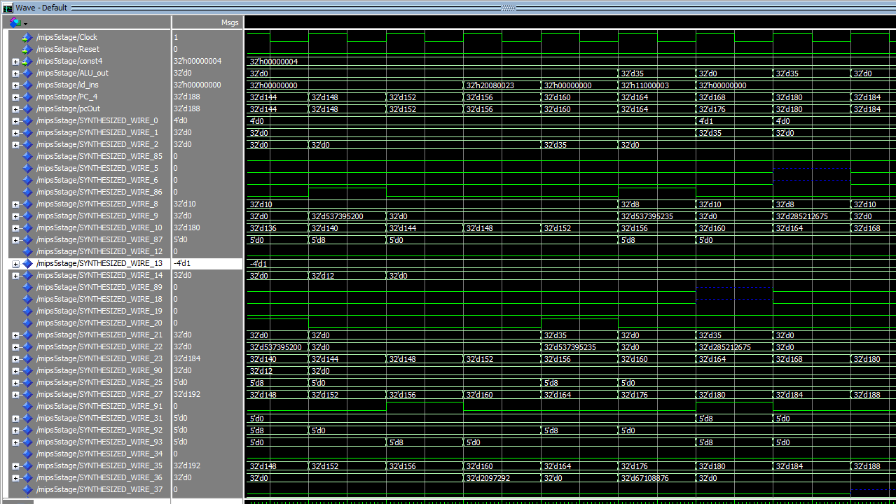

- [Part 5b] Implement a hazard detection unit (using VHDL) to support the following data dependent cases. Give simulation screenshots of correct forwarding for the cases described in the lab manual. (6 pts)

- [Part 5c] Connect your forwarding and hazard detection units to your pipelined processor and provide a simulation screenshot showing that your pipeline correctly executes the given test program. (6 pts)

I can get correct results from the output of ALU but the result is not going into the registers successfully since my hazard detection unit is not working well.

